Bat | 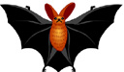
Bear | 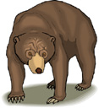
Camel | 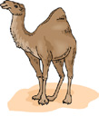
Duck | 
Dog | 
Elephant | 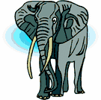
Fox | 
frog | 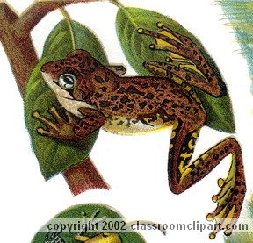
Giraffe | 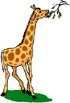
Horse | 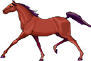
Kangaroo | 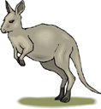
Lion | 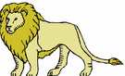
Monkey | 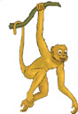
Snake | 
Zebra | 