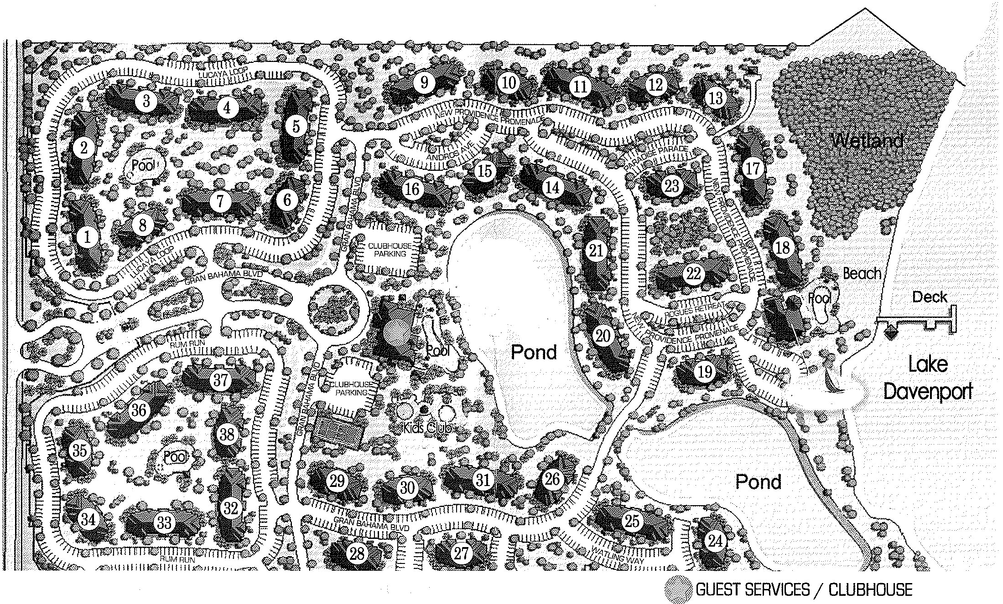
- Starting at number 7, cross Lucaya Loop, turn left in Gran Bahama Boulevard. Then turn right on the roundabout, pass the clubhouse parking and tennis court. Turn left. Follow Gran Bahama Blvd. Cross the bridge. Just on the right, you have number …………
- From the wetlands, walk between 17 and 18, turn right on the road. Then turn left on Paradise Parade. Walk between 14 and 21.
You are facing the ……………………

