



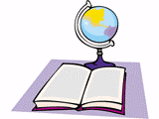


Sarah Dogon Fiche-outil N°30 :
EASTER CRAFT
- Voici une proposition d’activité manuelle pour des élèves de cycle II autour du thème de « Pâques »… Elle leur permettra de vivre ce temps fort de façon ludique et créative tout en y associant un bain linguistique en anglais. Il sera important d’associer aux consignes les gestes afin de rendre la compréhension plus aisée.
What you’ll need :
- 2 sheets of yellow paper
- 1 sheet of orange paper
- 2 paper fasteners / attaches parisiennes
- 2 large wiggle eyes or white paper (for the eyes)
- glue
- Scissors
- Pencil
- Black marker or dark crayon

How to make it:
- Trace child's hands onto yellow paper and cut out to make the wings (ailes) of the bird.
- Draw an oval onto the other yellow piece of paper. Cut out.
- Put the oval on the table and position the wings behind it (see photo).
- Then poke (percez) the fasteners through the paper to attach the wings. With the fasteners the wings can flap up and down.
- Draw a diamond (losange) for the beak (bec) and two legs and cut out from the orange paper.
- Fold the diamond in half to create the beak and glue one side of the diamond to the yellow paper so that the beak is three dimensional and can open and close.
- Glue wiggle eyes (or white paper) above the beak.
- Position the legs under the oval and glue them.
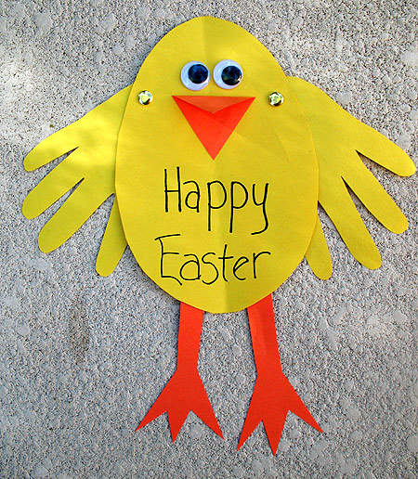
- Use the marker or dark crayon to write a big « HAPPY EASTER » on the front of the card :

